St Paul’s Catholic College
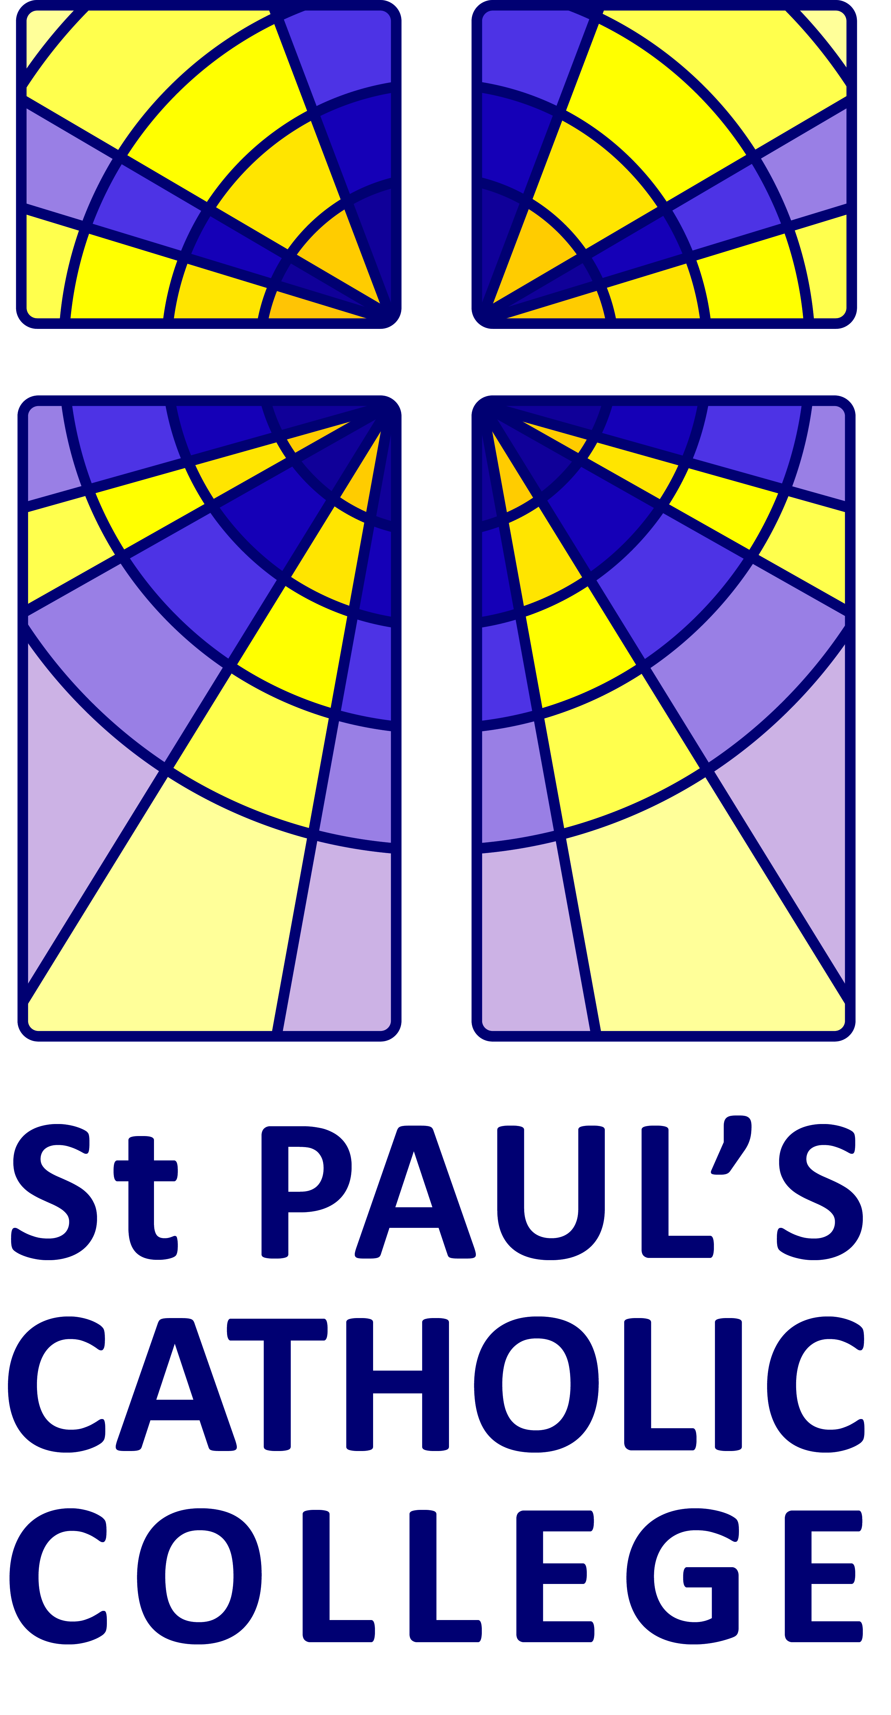
Jane Murray Way, Burgess Hill, West Sussex RH15 8GA
Tel: 01444 873898 Fax: 01444 873899
Email: office@stpaulscatholiccollege.co.uk
Headteacher: Mr Rob Carter
Chair of Governors: Mr Richard Goddard
CONSULTATION ON ADMISSION ARRANGEMENTS FOR ST PAUL’S CATHOLIC COLLEGE FOR 2018/19 ACADEMIC YEAR
St Paul’s Catholic College Governing Body invites your comments on their proposed admissions arrangements for 2018/19.
The consultation begins on 23 November 2016 for a period of 6 weeks and ends on 20 January 2017 (excluding Christmas break).
The proposed arrangements can be viewed on our school website www.stpaulscatholiccollege.co.uk and is also available from the school office on request.
Name:

Organisation (if applicable):

Address:

Contact Details:

Comments:

(please use additional paper if required:

Completed forms should be returned to:
St Paul’s Catholic College
Jane Murray Way, Burgess Hill, West Sussex RH15 8GA

